Q1:

My guess on the rank from largest to smallest is:

1. Process management
2. Memory management (high and low level)
3. Shell and shell applications
4. Drivers for hardware devices (Ethernet and tty devices)
5. Inter-process communication
6. Process coordination
7. Local file system
8. Remote disk system
9. Remote file system
10. Network protocols
11. Configuration program (specifies which device drivers to use)

The actual counts of lines of code ranked from largest to smallest is (with list of files):

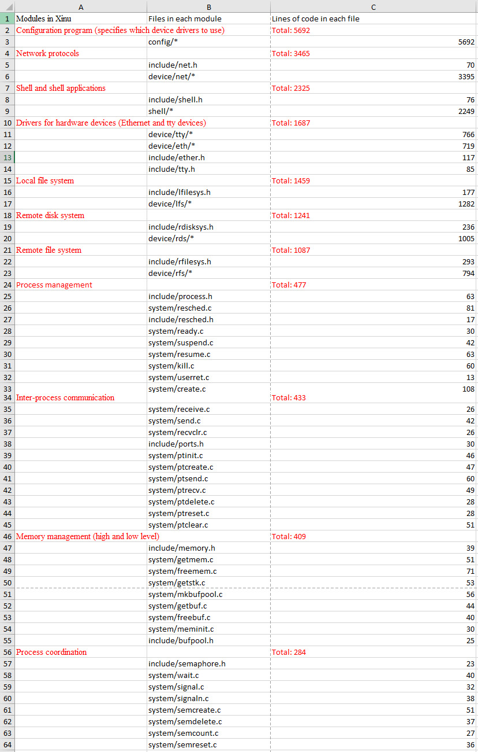

Q2:

Pie chart of the counts

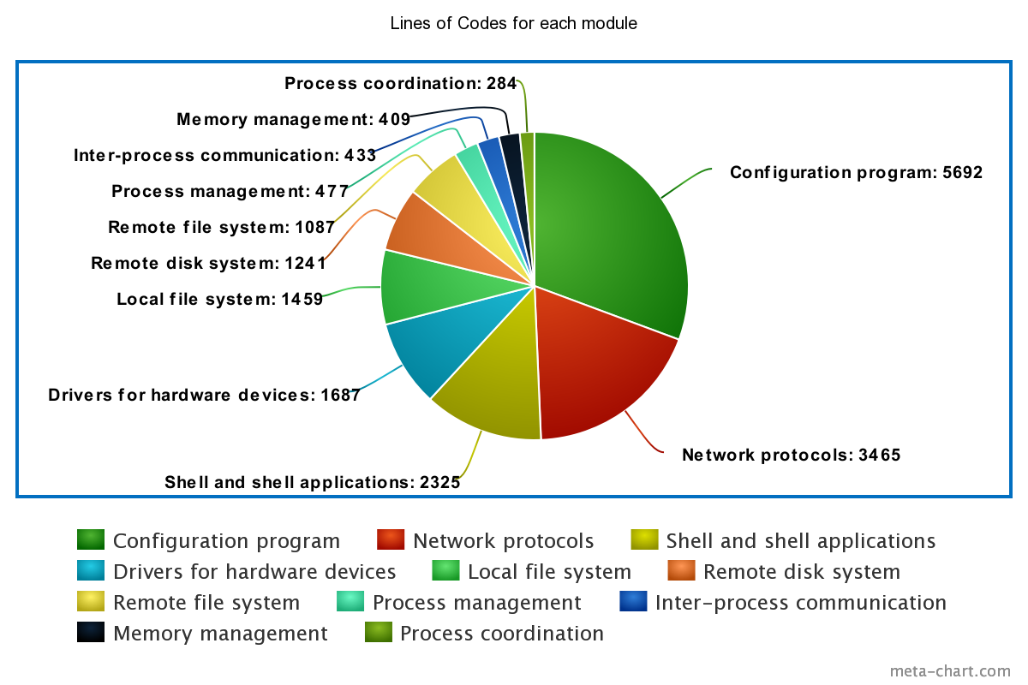

Q3:

1. The module that agrees the most with your guess: Shell and shell applications
2. The module furthest from your guess: Configuration program

Q4:

The module “Configuration program” surprised me the most. I didn’t realized configuration can take so many lines of code because I thought it would be just a small addition to the whole operating system which I thought would be fundamentally larger.